**Code of Practice for the Co-ordination of Street Works and Works for Road Purposes and Related Matters HAUC(England) Edition**

Guidance Document

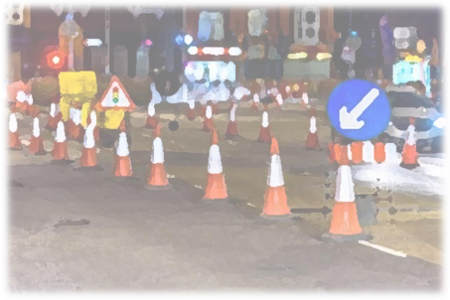ISSUED BY HAUC (ENGLAND)

1

**Document Control Sheet**

Document prepared by: Samantha Brothwell, Jan Chapman, Helena Kakouratos, David Latham as part of the revision of Appendix B of the Co-ordination Code. Reviewed by Sally Kendall.

Approved by Peter Loft and Jeff Elliott (Joint Chairs HAUC England) 

Record of Issue

| Title: | Code of Practice for the Co-ordination of Street Works and Works for Road Purposes and Related Matters Guidance Document |
| --- | --- |
| Status: | For publication |

| Issue | Status | Author | Date | Version description |
| --- | --- | --- | --- | --- |
| 1.0 | First  impression | SB &  SK | January  2022 | First impression for publication as approved by Peter Loft and Jeff Elliott Joint Chairs HAUC England |
|  |  |  |  |  |
|  |  |  |  |  |
|  |  |  |  |  |
|  |  |  |  |  |

2

**Ancillary Activities Guidance**

Extract from revised draft Appendix B of the Code of Practice for the Co ordination of Street Works etc. This document is 8 pages long. Issued December 2023 by HAUC (England) on behalf of DfT

**2.1 Supplementary information on ancillary activities**

**What is considered to be supplementary information or activities?**

A permit application must be sent for all excavation works and for certain non excavation works. Each permit can only cover a single street. Sometimes these primary works require other related activities which can disrupt traffic flow to take place on the same street, or adjacent streets separate to the works’ footprint to ensure the works can be completed, including:

1. Placement of traffic lights heads or other traffic control

2. Placement of site welfare facilities

3. Placement of site compound or material storage

4. Placement of spoil compound for works

These four items are considered as supplementary information and the use of any of them must be recorded in Street Manager as ‘ancillary information’ on the permit created for the primary works. This list is taken from NCT03 in the national permit conditions. Items considered as supplementary information **do not require a separate permit as well**, with the exception of certain scenarios explained below, where an optional permit can be used.

**Guidance on where ancillary information is needed**

If the ancillary activities are within the works’ footprint or in the same street close to the works, there is no need to send ancillary information.

Where the ancillary activities are on an adjacent street, or they are on the same street but remote from the work site then ancillary information should be sent.

➢ If the ancillary activities are not within the works’ site or on the same street and not on an adjacent street, then an optional permit should be sent instead of ancillary information.

The ancillary information must be added at the time when the permit application is made or shortly thereafter - in any event within the authority response period.

The diagrams below show some examples of where ancillary information should be sent or where an optional permit is appropriate.

3

➢ Depending on the method of communication with Street Manager used by any organisation, the ancillary information can be added at the same time as creating the permit or shortly thereafter.

➢ Authorities should look out for ancillary information on permits when they are assessing them.

**Illustrative Examples**

**Example 1: Ancillary activities within or close to works’ site –** No ancillary information required as included in permit application.

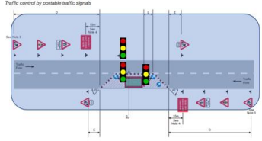

**Example 2: Ancillary activities on adjacent streets –** Ancillary information required**.**

Ancillary items shaded in pink

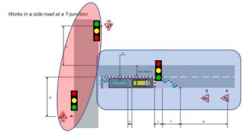4

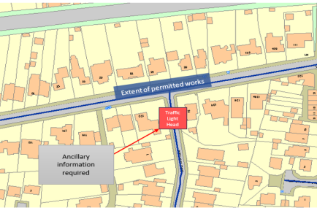**Example 3: Ancillary Information and Optional Permit**

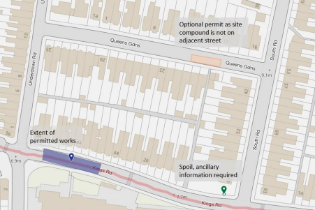5

**Example 4: Items on different streets**

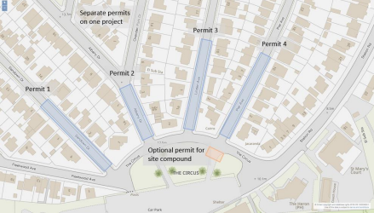

**When things change**

When works start on site and it becomes necessary to use one or more of the listed ancillary activities, the national conditions require ancillary information should be added to the primary permit.

If ancillary information has been added in error, or, when works start it is found that it is no longer required, it can be removed from the permit.

The adding, amending, or removing of any ancillary information is not a chargeable notification.

**Applying NCT03**

Regulation 9(3A) of the 2007 permit regulations requires supplementary information that is known about by the applicant at the time of the application to be provided at the same time as the permit application. NCT03 states that, if there are changes to these ancillary activities, either in the street to which the application relates or in an adjacent street that become known about within the duration of the permit, the authority must be notified via Street Manager.

NCT03 should be added, therefore, to a permit when adding ancillary information.

NCT03 should also be added if it might be likely that ancillary activities will be

6

needed at some point during the works. To note, the requirement is to notify the authority. It is not a breach of the condition if NCT03 is used but no ancillary activities take place.

To aid coordination, it is strongly recommended that promoters should add NCT03 using a change request when recording new ancillary information when works are in progress, and that the authority does not charge for this change request.

**Ancillary information cross boundary**

When any ancillary information needs to be recorded on streets maintained by differing authorities, it is strongly recommended that all USRNs are recorded on the ancillary information on the primary permit, and an ‘optional permit’ is created for any USRNs in a different authority, including National Highways, to ensure they are aware.

**Ancillary information or optional permit?**

The table below provides practical guidance on when to send ancillary information or an optional permit.

Table: Ancillary Information and Optional Permit Scenarios

| **Scenario** | **Recommended**  **Transaction** | **Process** |
| --- | --- | --- |
| 1. Ancillary activities  placed within the  works’ footprint. | Permit – no additional  transaction required. | N/A |
| 2. Ancillary activities in the same street close to the works. | Permit – no additional  transaction required. | N/A |
| 3. Where the ancillary activities are on an  adjacent street or they are remote from the  work site. | Add ancillary information to existing permit. | Via Street  Manager at time of sending  permit or within  response period |
| 4. Ancillary items not on the same or  adjacent street. | Optional Permit. | Street Manager |
| 5, Ancillary items for  any USRNs in a  different authority,  including National  Highways | Optional Permit | Street Manager |
| 6. Major works  affecting more than  one USRN. | One permit per USRN  needed. No need to send ancillary info on permit for each USRN - send Optional Permit instead. | Street Manager |

7

| 7. Addition of ancillary activities after permit started. | Using the appropriate  scenario as per this table | Street Manager  (if 3, 4,5) |
| --- | --- | --- |

**When works are complete**

When works are complete, all ancillary activities must also be removed from the highway at the same time the primary works site is cleared, or they could be subject to other regulations.

➢ Once a works stop has been issued on a permit which has ancillary information recorded, Street Manager will no longer show the ancillary details on the map. However, the details will still be visible on the permit.

ENDS

8